Maximum marks for Assignment: _9_ Assignment Declaration Date: 9/10/2025
Assignment Submission Date: 13/10/2025 Assignment assessment declaration Date by faculty: 13/10/2025

Q. NO | Question Statement | Level of mapping & NO. |  |  | Blooms Level | Mark
Q. NO | Question Statement | CO | PO | PSO | Blooms Level | Mark
Q1. | Consider the following page reference string 1, 2, 3, 4, 2, 3, 4, 5, 6, 7, 3, 2, 4. The no of frames=3 calculate page hit & fault 1) FCFS 2) LRU | CO6 | PO1 |  | 3 | 4
Q2 | Explain demand paging in short | CO6 | PO1,PO2 |  | 2 | 4
Q3 | Compare the Terms. 1. paging & segmentation  2. Contiguous & Non-contiguous memory allocation.  3. fixed Partitioning and Dynamic Partitioning. | CO6 | PO1 |  | 3 | 9
Q4 | Difference between internal & external fragmentation. Which one occurs in paging? | CO6 | PO1 |  | 4 | 4
Q5 | Explain the concept of swapping, paging & need for paging | CO6 | PO1 |  | 2 | 6
Q.6 | What is virtual memory? Different techniques used for V.M. | CO6 | PO1 |  | 1 | 6
Q.7 | Short note on: Page replacement need and techniques of page replacement policies. | CO6 | PO3 |  | 2 | 4
Q.8 | Consider the following page reference string: 1,2,3,4,2,1,5,6,1,1,2,3,7,6,3,3,1,3. The no frames=3 & 4. Calculate page hit and page fault 1) Optimal 2) LRU | CO6 | PO1,PO3 |  | 3 | 4
Q.9 | Write a short note on the following with a diagram  i) VM with Paging  ii) VM with Segmentation | CO6 | PO1,PO2 |  | 2 | 8
Q.10 | What is Thrashing? | CO6 | PO1 |  | 1 | 4
Q.11 | Explain Segmentation using a suitable example in brief | CO6 | PO2 |  | 2 | 3
Q.12 | What is fragmentation? Explain internal and external fragmentation | CO6 | PO1 |  | 2 | 6
Q.13 | Explain techniques of managing memory using first fit, best fit and worst fit with a suitable example? | CO6 | PO2 |  | 2 | 4
Blooms level | Blooms Taxonomy terms
6 | 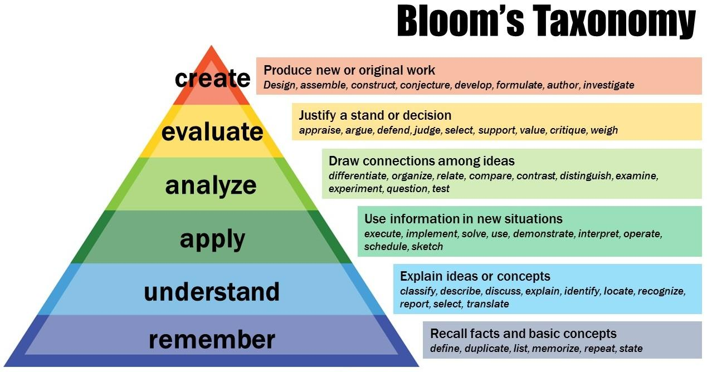
5
4
3
2
1

Subject In-charge HOD

